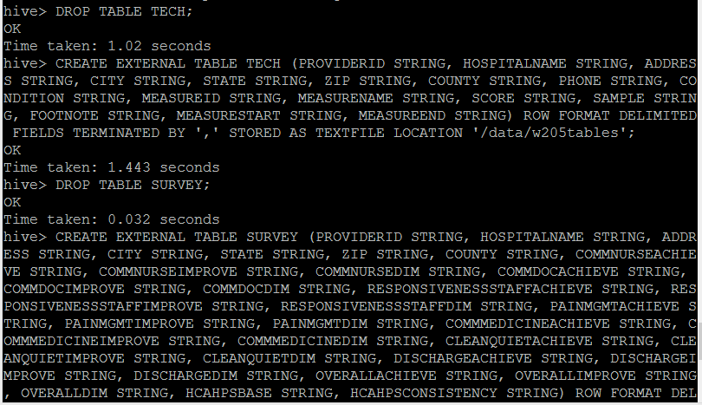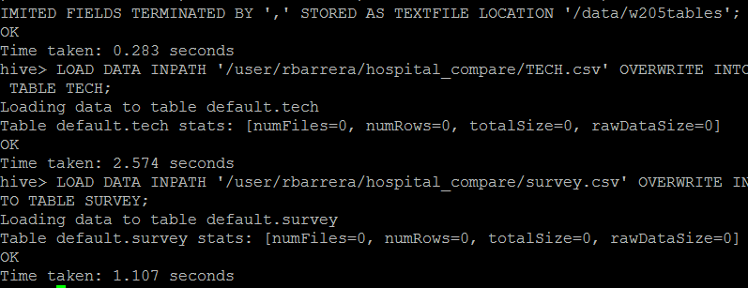

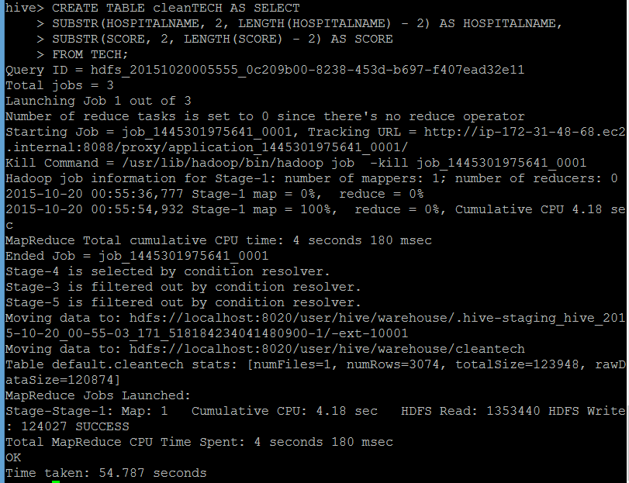

Testing correctness of TECH table. As you can see, the TECH table is corrupt entry wise.

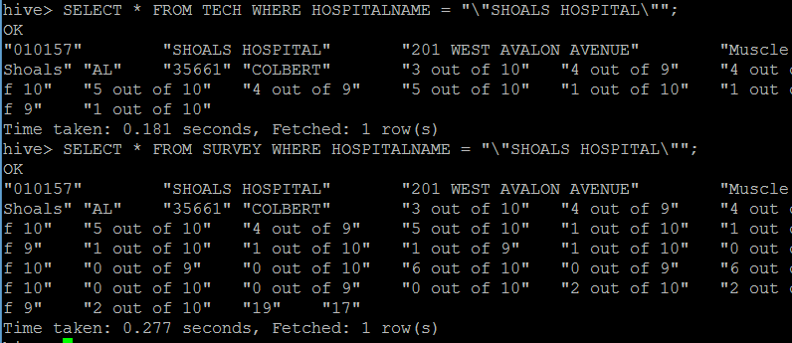

Loading failed



Reloading says the hdfs file is gone

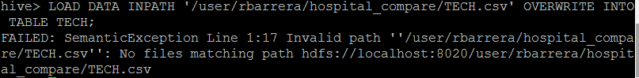

Schema for TECH is correct

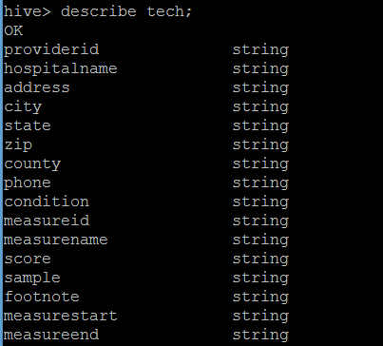

Reloading data again and querying shows it loaded just fine

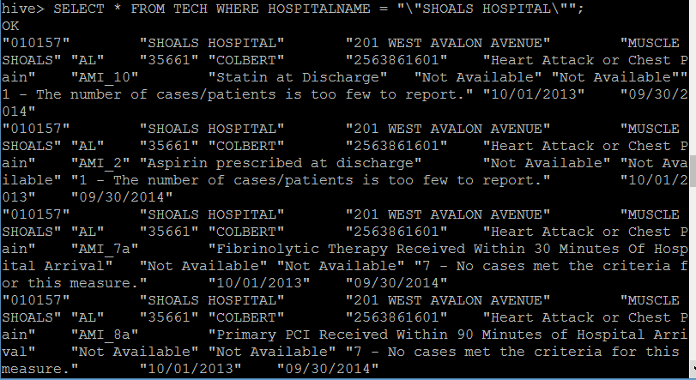

Creating the new table from TECH

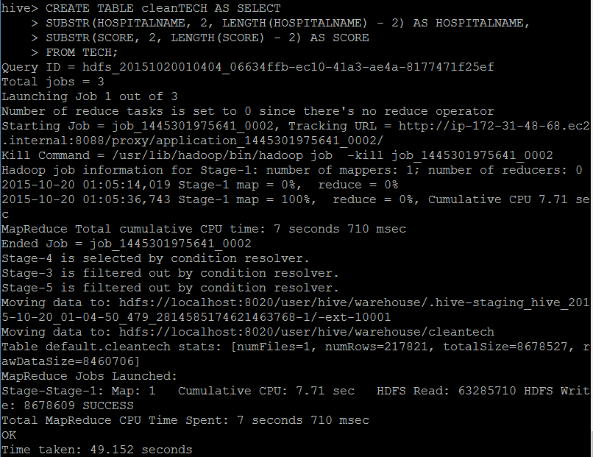

Testing CleanTECH

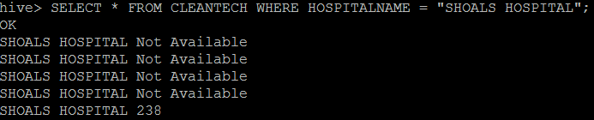

Create and load Survey table

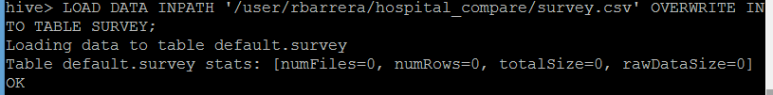

Test table

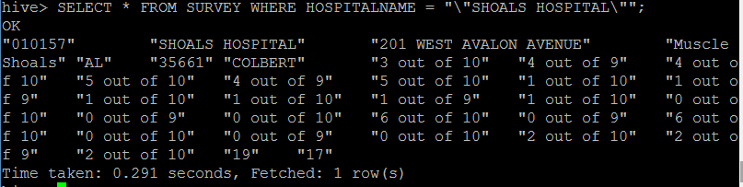

Testing casted TECH table

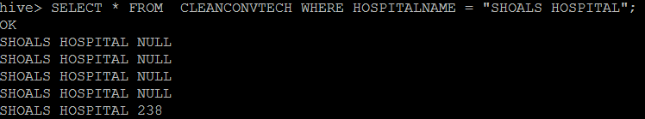

Testing null filtered version

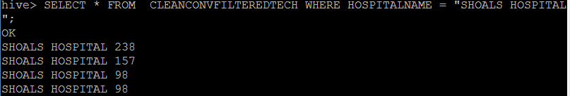

Completed version



Working with survey data



Casting



Joining results still OK this time

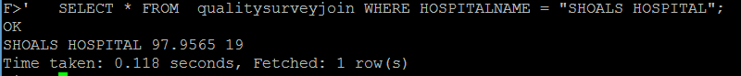

Computing correlation

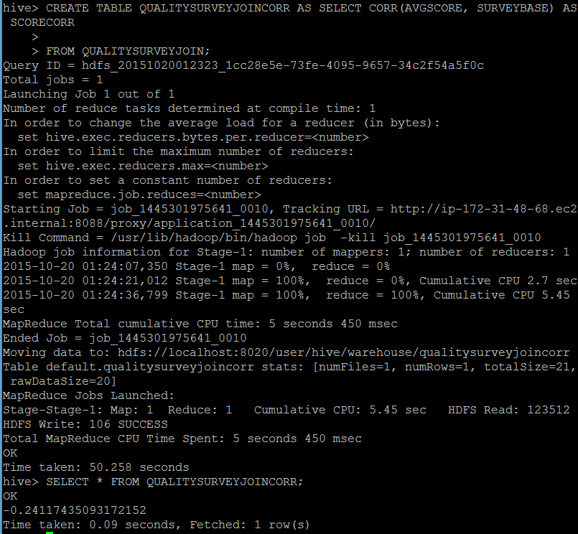

It worked this time. It refused to work previously because of the issues